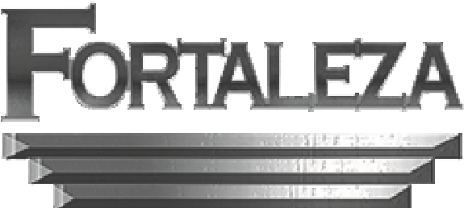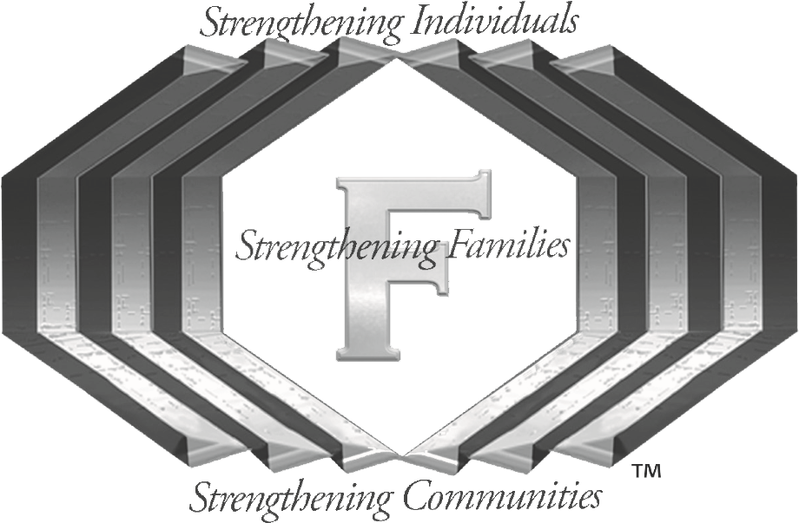

**Certified by the Ohio Department of Mental Health & Addiction Services**

**(OMHAS)**

**Strengthening Individuals**

**Strengthening Families**

**Strengthening Communities**

**FORTALEZA, LLC.**



**Fortaleza, LLC**

Fortaleza is committed to helping rebuild the lives of individuals, families, and the communities in Cuyahoga,Lorain, and Medina Counties

Fortaleza provides quality services in Spanish & English and is open to the entire Lorain,Cuyahoga, and Medina and surrounding communities

**“Addiction is a Disease”**

**“TODAY IS A CHOICE”**

**Call today**

**FORTALEZA in Cuyahoga County:**

**2301 Scranton Road**

**Cleveland, OH 44113**

**(216) 273-6998**

**Fax: (216) 566-9974**

**FORTALEZA in Lorain County:**

**41641 N. Ridge Road, Suite B**

**Elyria, OH 44035**

**(440) 324-7406**

**Fax: (440) 324-3609**

**FORTALEZA in Medina County:**

**1839 Pearl Rd, Suite 201 & 202**

**Brunswick, OH 44212**

**(330) 460-0020**

**Fax: (330) 225-4945**

*Email:*

[**generalinfo@fortaleza-lorain.com**](mailto:generalinfo@fortaleza-lorain.com)

*Fortaleza website*:

**fortalezatreatmentcenters.com**





**Begin Your Program of Recovery by following this EASY Sign-Up process**\*

1. Client contacts Fortaleza by phone, to set up appointment and complete initial paperwork
2. Client meets with Counselor to complete the AOD assessment
3. Client takes the initial Drug Test on site
4. Client meets with medical staff to complete the Med/ Somatic requirements
5. Client meets with the Medical Physician to complete the medical assessment

*not all services available at allsites

•

**Most Insurances are Accepted:**

🞟Anthem BlueCross & BlueShield 🞟Medicaid 🞟Medicare 🞟United Healthcare Community 🞟Molina 🞟Buckeye 🞟Care Source 🞟Humana 🞟Medical Mutual 🞟Aetna 🞟United Health Care 🞟Paramount

**Cash clients accepted**

**Will work with indigent clients**

**En FORTALEZA lo recibimos con respeto.**

**Estamos comprometidos a ayudarlos.**

•

FORTALEZA offers these Medical Assisted Treatment Services:

* Intake
* AOD Assessments
* Med/Somatic evaluations
* Urinalysis:Testing/lab analysis
* Intensive Outpatient Groups
  + IOP
  + O.P.
  + Recovery Maintenance
* Family Support
* Case Management
* Individual AOD Counseling
* Intervention
* Crisis Intervention
* Referral & Information
* Group Counseling
* Ambulatory Detox

**Fortaleza’s Dynamic Team**

Each office is equipped with a complete team to meet needs of our clients. Each team consists of the following personnel:

Front office specialists

Group monitors

Security & safety personal

Licensed and certified medical staff

Medical Physicians, LPN’s, Medical Assistants

Certified and Licensed Counselors Case Management Team

Transportation Team

Administrative Team

Mental Health Counselors

**Our staff is also 90% Bilingual (Spanish)**

**Visit us at:**

**Located in**

**Cuyahoga County:**

2301 Scranton Road,

Cleveland, OH 44113

(216) 273-6998

Fax: (216) 566-9974

**Located in**

**Lorain County**

41641 North Ridge Road, Suite B,

Elyria, OH 44035

(440) 324-7406

Fax: (440) 324-3609

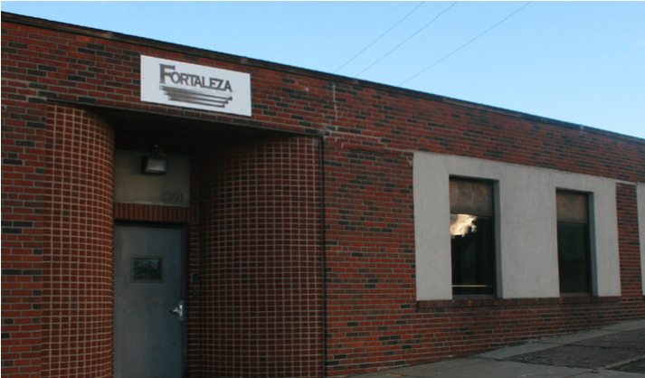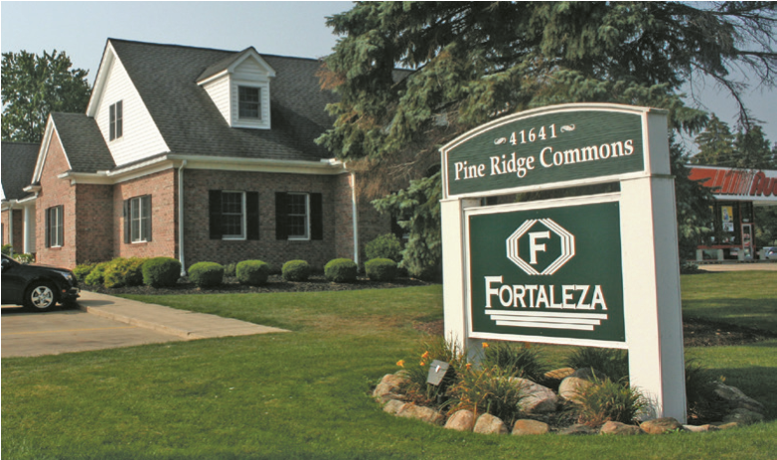

**We welcome you with respect at Fortaleza.**

**We are committed to helping you**

**Fortaleza Strengthens Individuals**

**Strengthens Families**

**Strengthens Communities**