COST OF THE DRAGON
Public Service Announcement
Poster Contest
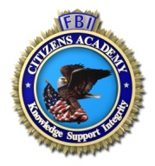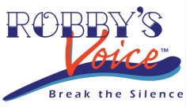

FBI Future Agents in Training Alumni / FBI Cleveland Citizens Academy Foundation /
Robby’s Voice / DEA Cleveland / FBI Cleveland

ENTRY FORM

Student’s Name: ________________________________________________________

Address: _______________________________________________________________

Phone Number: ________________________

Email Address: ________________________

Grade: _______________________________

Parent/Guardian Name: ___________________________________________________

Address: _______________________________________________________________

Phone Number: ________________________

Email Address: ________________________

I understand that my artwork may be displayed at various locations around
Northeast Ohio and I give my permission for my name to be attached.

Student: ____________________________________________ Date: __________
(Signature)

Parent/Guardian: ____________________________________ Date: __________
(Signature)

