COST OF THE DRAGON
Public Service Announcement
Poster Contest
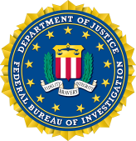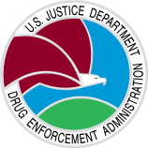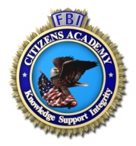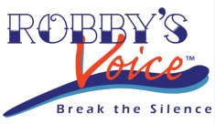

FBI Future Agents in Training Alumni / FBI Cleveland Citizens Academy Foundation /
Robby’s Voice / DEA Cleveland / FBI Cleveland

OFFICIAL RULES AND REGULATIONS

Background:

In an effort to combat the growing epidemic of prescription drug and heroin abuse, the FBI and DEA have released “Chasing the Dragon: the Life of an Opiate Addict,” a documentary aimed at educating students and young adults about the dangers of addition.

The censored version can be found at: www.FBI.gov/ChasingTheDragon

Heroin use and the misuse of prescription opioids are increasing in pandemic proportions everywhere, especially here in Northeast Ohio. Overdose deaths in our area are among the highest in the country. Unfortunately, these numbers are only expected to increase. Recent statistics show that the average age of the first-time heroin user is between the ages of 12 and 17.

In an effort to raise awareness on this epidemic, the FBI Future Agents in Training (FAIT) Alumni, FBI Cleveland Citizens Academy Foundation (FBICAF), Robby’s Voice DEA Cleveland and the Cleveland Division of the FBI are working together to spread the word about the Opiate problem.

About the contest:

Teens in grades 7th -12th are invited to create and submit a poster that focuses on the consequences of using heroin and/or misuse prescription opioids.

Entitled: Cost of the Dragon
Rules and Regulations:

- This competition is available to all students in grades 7th -12th.

- Individuals must complete the Entry Form, Media Release, Submission Authorization and submit the Poster by 5:00 pm on April 30, 2017. Poster entries will not be accepted if submitted after this date.

- Each participant must read and agree to the official rules and regulations to be considered eligible for the contest (submission authorization).

- Poster must only contain original and non-copyrighted material. No copyrighted music, branded material, logos, etc., may be used without express written permission from the copyright or trademark holder.

- The FAIT Alumni, FBICAF, Robby’s Voice, Cleveland DEA and the Cleveland FBI reserve the right to disqualify any submission for any reason deemed necessary.

- Submitted posters will not be eligible if they contain or appear to contain:

- Obscene material or language
- Nudity, profanity, or gratuitous violence
- Endorsement of illegal drug use, alcohol abuse, prescription drug abuse,
or any other illegal activity
- Derogatory characterization of any person or group
- Any copyrighted or trademarked materials without express
written consent from the copyright or trademark holder

Submitted poster will be judged:

Originality of Presentation (Maximum 50 points)
Effectiveness and Relevance (Maximum 30 points)
Content (Maximum 20 points)

Awards:

The contest will be broken down into three grade categories:
7th – 8th grade / 9th -10th grade / 11th – 12th grade

Each grade category will have two winners:
1st place will receive $100.00 cash award
2nd place will receive $ 75.00 cash award

Winning Posters may be displayed in public venues.

Awards will be presented at the Cleveland FBI Field Office

Prize money provided by the FBI Cleveland Citizens Academy Foundation

Posters should be 24”x36”

Posters should be sent to or dropped off at:

FBI
1501 Lakeside Avenue
Cleveland, OH 44114 Attention: Community Outreach Specialists

Must Submit: Important Dates:
• Entry Form • Contest Opens: February 1, 2017
• Submission Authorization • Contest Ends: April 30, 2017
• Media Release • Winners Announced: May 30, 2017
• Poster

Questions? E-mail Tamara Larkin at Tamara.Larkin@ic.fbi.gov or call us at 216-622-6691

