COST OF THE DRAGON
Public Service Announcement
Poster Contest
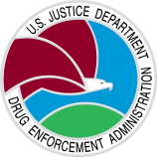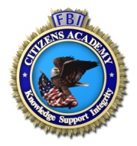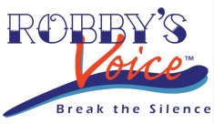

FBI Future Agents in Training Alumni / FBI Cleveland Citizens Academy Foundation /
Robby’s Voice / DEA Cleveland / FBI Cleveland

SUBMISSION AUTHORIZATION

________________________________ ____________________________________
STUDENT’S NAME PARENT’S/LEGAL GUARDIAN’S NAME

As parent and/or legal guardian of the child named above (“Child”), I authorize my Child’s participation in the Cost of the Dragon public service announcement (PSA) Poster contest (the “Contest”). I grant the FBI Future Agents in Training Alumni (FAIT), FBI Cleveland Citizens Academy (FBICAF), Robby’s Voice, DEA Cleveland and FBI Cleveland assigns, and successors in interest a worldwide, perpetual, irrevocable license to use, license to others to use, reproduce, edit, prepare derivative works, publish, broadcast, distribute copies to the public, and perform and display publicly in any manner and for any purpose the poster created and submitted by or on behalf of my Child for the Contest (the “Submission”). I further authorize FAIT, FBICAF, Robby’s Voice, DEA Cleveland and FBI Cleveland to use the Child’s name, likeness, school name, grade level, or other biographic information provided in connection with the Submission.
On my own and my Child’s behalf, I certify that the Submission is the Child’s original work and I have the authority to assign these rights to the Submission and content contained therein. I understand the Submission will not be returned, FAIT, FBICAF, Robby’s Voice, DEA Cleveland and FBI Cleveland have no obligation to use the Submission.

I release and discharge FAIT, FBICAF, Robby’s Voice, DEA Cleveland and FBI Cleveland, its employees, officers, directors, volunteers, licensees, designees, successors, and assigns from any and all claims, actions, and demands arising out of or relating to use of the Submission. I acknowledge that neither I nor my Child expect remuneration or compensation from FAIT, FBICAF, Robby’s Voice, DEA Cleveland and FBI Cleveland, or any person or entity for the right and permission to use the Submission, as I grant such right and permission because of my desire to help FAIT, FBICAF, Robby’s Voice, DEA Cleveland and FBI Cleveland in its mission to help raise awareness in the fight against the heroin epidemic.

I represent my Child and I have the right and authority to enter into this Authorization and Release and that the rights granted herein will not conflict with or violate any commitment or understanding I have with any other person or entity, and have read this document and fully understand its content.

ACKNOWLEDGED AND AGREED on this date set forth below:

Student: ____________________________________________________________________________

Parent/Legal Guardian Signature: ________________________________________________________

Parent/Legal Guardian Printed Name: _____________________________________________________

Date:______________________ Relationship to Student: _____________________________________

Phone: ____________________ E-Mail: ___________________________________________________

Yes, my child and I have read and will abide by the rules and regulations for this contest.

